Bo-Nash Bonding Powder, Angelina, Iron Shoe & Ironing Board Cover
Good afternoon Beryl!
I sifted through the 120 photos on the Fae Warrior CD to find a couple of fairly representative photos of the wings I made using Bo-Nash Bonding Powder and Angelina fibers for the Future Fashion Folio at Costume Con 26 in San Jose, CA April 2008.
As my friends so gleefully pointed out, this costume was awarded the "Best in Folio" (Best in Show) as my first time attending this event.
The wings have a base of a black chiffon used to show on the side seen when viewing me from the front, with the fibers blended from 10 different staple and heat fix color options to match the designer Dana Teh's color description.The wings are sewn onto a 8 gauge wire frame with gold bias tape covering the edges and include prismatic glitter mixed in with the fibers during the bonding process for more texture.Lumiere paint outlines the wing veins and accents some of the acrylic gems.
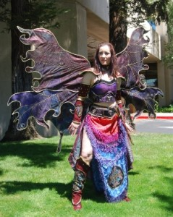COSTUME-CON is an annual conference about costumes. The convention has its roots in science fiction and fantasy conventions and historic re-enactment type events, but all forms of costuming are welcome, including anime, fursuit, etc. Costume-Con is a "travelling" national-level convention, and is in a different city and run by a different committee each year. You can read more about how it came about, where it has been and where it is going at: http://www.costume-con.org/about.shtml
Locally I participate in the Beyond Reality Costumers Guild, part of the International Costumers Guild, and am considered to hold the rank of "Master Costumer" for competition purposes. This year I'm branching out and teaching on costuming tracks at Beyond Con, Norwescon (Easter Weekend in SeaTac) and Costume College (August in LA).
My group has already been having a lot of fun with the new iron shoes and ironing board covers- one even took the excess scraps from the cover and made a board to use with her hot glue gun! (It's worked wonderfully, we were making ribbons for the hall costume awards to be handed out at Norwescon on Sunday afternoon.)
Jonnalyhn Wolfcat,
Dreaming of a peaceful and costumed world

